**INDEX**

|  |  |  |
| --- | --- | --- |
| **No** | **Contents** | **Page** |
| 1 | Introduction | 05 |
| 2 | Problem Definition | 06 |
| 3 | Need for Computerization | 07 |
| 4 | Objectives and Scope of the System | 08 |
| 5 | System Analysis | 09 |
| 6 | Feasibility Study | 10 |
| 7 | Advantages of the System | 12 |
| 8 | Hardware & Software Requirements | 13 |
| 9 | Entity Relationship Diagram | 20 |
| 10 | Use Case Diagram | 20 |
| 11 | Class Diagram | 21 |
| 12 | Activity Diagram | 22 |
| 13 | Sequence Diagram & Component | 24 |
| 14 | Collaboration Diagram | 26 |
| 15 | Input Screens | 27 |
| 16 | Limitations & Future Enhancements | 47 |
| 17 | Conclusion | 48 |
| 18 | References and Bibliography | 49 |

**INTRODUCTION**

Chess is a two-player strategy board game played on a checkered board with 64 squares arranged in an 8×8 grid. The game is played by millions of people worldwide. Chess is believed to be derived from the Indian game chaturanga sometime before the 7th century. Chaturanga is also the likely ancestor of the Eastern strategy games xiangqi (Chinese chess), janggi (Korean chess), and shogi (Japanese chess). Chess reached Europe by the 9th century, due to the Umayyad conquest of Hispania. The pieces assumed their current powers in Spain in the late 15th century; the modern rules were standardized in the 19th century.

Play involves no hidden information. Each player begins with 16 pieces: one king, one queen, two rooks, two knights, two bishops, and eight pawns. Each piece type moves differently, with the most powerful being the queen and the least powerful the pawn. The objective is to checkmate the opponent's king by placing it under an inescapable threat of capture. To this end, a player's pieces are used to attack and capture the opponent's pieces, while supporting each other. During the game, play typically involves exchanging pieces for the opponent's similar pieces, and finding and engineering opportunities to trade advantageously or to get a better position. In addition to checkmate, a player wins the game if the opponent resigns, or (in a timed game) runs out of time. There are also several ways that a game can end in a draw.

The first generally recognized World Chess Champion, Wilhelm Steinitz, claimed his title in 1886. Since 1948, the World Championship has been regulated by the Fédération Internationale des Échecs (FIDE), the game's international governing body. FIDE also awards life-time master titles to skilled players, the highest of which is Grandmaster (GM). Many national chess organizations have a title system of their own. FIDE also organizes the Women's World Championship, the World Junior Championship, the World Senior Championship, the Blitz and Rapid World Championships, and the Chess Olympiad, a popular competition among international teams. FIDE is a member of the International Olympic Committee, which can be considered recognition of chess as a sport. Several national sporting bodies (e.g. the Spanish Consejo Superior de Deportes) also recognize chess as a sport. Chess was included in the 2006 and 2010 Asian Games. There is also a Correspondence Chess World Championship and a World Computer Chess Championship. Online chess has opened amateur and professional competition to a wide and varied group of players.

Since the second half of the 20th century, chess engines have been programmed to play with increasing success, to the point where the strongest programs play at a higher level than the best human players. Since the 1990s, computer analysis has contributed significantly to chess theory, particularly in the endgame. The IBM computer Deep Blue was the first machine to overcome a reigning World Chess Champion in a match when it defeated Garry Kasparov in 1997. The rise of strong chess engines runnable on hand-held devices has led to increasing concern about cheating during tournaments.

**PROBLEM DEFINATION**

To design and develop chess game web application which could be accessed in browser and provide features to play online by login and sending request to other online available players.

Providing real time chatting feature to players while playing.

**NEED FOR COMPUTERIZATION**

Earlier we used to play chess using physical chess board and pieces but current age is completely technology based. We are leaving in world where everything is driven by technology, everyone use computers, laptops, digital devices every day in routine life. Mobiles are used by everyone from smallest to eldest peoples. Hence designing online chess game and making it available on online will made this game accessible to wide range of application.

Currently many chess applications are available on internet but very few provides feature to play it online with remote player. But through this app we will be able to send play chess with anyone from any corner of world. That means you can send request from your home setting on sofa to your facebook friend from England and play game with him as well as can chat with him while playing.

**OBJECTIVE AND SCOPE OF SYSTEM**

**Objectives :**

a) To provide a user-friendly interactive environment to the users of the application that helps them to play and communicate with a lot of ease.

b) To provide help to the users in playing the chess that is the different moves of the different pieces etc are being explained to the users, if they require.

c) The care is taken that the user finds the same chatting mechanism as he is normally used to.

d) Since there exists client and server as the project is based on client server architecture, where server is serving as a mediator in between the players and the client is making request to server as well as doing all the part that is related to playing logic.

e) The care has been taken that the application has less CPU usage, so that other applications can also be performed, if required.

**Scope :**

Basically this project has two main purposes: Firstly, to encapsulate the chess gaming and chatting in one application so that a user can easily view and use both of them on a single window.

Secondly,to make these two applications to run simultaneously on the network. Generally, the chess game is normally played against the human user and the computer on which the user is operating, so the need is to make the chess game being played against two human users on two different machines on the network, no matter their physical location and as well as allowing chat among those two users.

**SYSTEM ANALYSIS**

This app is basically is a chess game hence the user will be player who will login with unique login id to play the game.

Anyone can login at anytime from anywhere using app link to the app to use app and play.

After login user can view received invitation for playing from other users all over the world he can accept or reject the request.

User can view sent request as well with its status and he can cancel the request anytime.

User can delete the accepted and sent or received request from app.

User can open the game and start playing with other users after accepting the request.

We can sent/receive request to/from multiple users and can play with many users at a same time.

**The Pieces and The Rules:**

1) The KING:

The King is the most important piece. When it is trapped so it cannot move without being captured, then the game is lost. This trap is called checkmate. The King can move one square in any direction. A King can never move into check, or onto a square where it can be captured by an opponent's piece. If a King is not in check, and no other legal move is possible, then the position is said to be in stalemate. A stalemated game is a draw, or a tie.

2) The QUEEN:

The Queen is the most powerful piece.The Queen can move to any square in any direction as long as her path is not blocked. Her range and the ability to attack many pieces an once are the source of her power.

3) The ROOK:

The Rook is the next very powerful piece after Queen. The Rook can move to any square along its file or row as long as its path is not blocked. Its range is the source of its power.

4) The BISHOP:

The Bishop comes next to Rook in terms of power. The Bishop can move to any square along its diagonals as long as its path is not blocked. Its range is the source of its power.

5) The KNIGHT:

The Knight is nearly as powerful as the Bishop. The Knight is the only piece that can hop over other pieces in an L-shaped path. This ability makes it particularly powerful in the early stage of a game when the board is crowded with pieces.

6) The PAWN:

The Pawn is the least powerful piece because of its poor mobility. The Pawn may move only one square forward if its path is not blocked. However, it may move as an option one or two squares forward on its first move only. It may capture only diagonally one square. It may not capture forward. It may not move backward. The lowly Pawn usually does not last long, but if it is able to reach the 8th row or rank, then it can promote itself to any other piece except the King. A Pawn thus promoted is replaced by that piece. Therefore, it is possible to have more than one Queen, or two Rooks, Bishops, or Knights on the board at one time.

**How to play?**

A. How to make move (It is a two-click process):

The chess game is fully mouse oriented and key board is not functional. The user can make a legal move by performing following operations.

* First Click:
  + On the square containing the piece which the player wants to move. (The player can move only his piece), the square gets highlighted by GREEN colour.
* Second Click:
  + - The square where he want the piece to move.

**How to capture opponent piece:**

* First Click:
  + On the square containing the piece which the player wants to move. (The player can move only his piece), the square gets highlighted by GREEN colour.
* Second Click:
  + The square containing the opponent piece which the player wants to capture.

**C. How to reconsider a piece to move (Deactivating the selected piece):**

Once the user as clicked on the piece to move and rethinks on the piece to move, for this he can click on any of his other piece, the highlighted square will be de-activated and he can start over again. Single Click on any of your own piece.

**D. How to perform a castling:**

To make any castling, whether o-o (short castling) or o-o-o (long castling) the user has to perform following operation:

* First Click:

On the square containing the King.

* Second Click:

On the square where the king will be placed after castling.

E. How to perform an en-passant:

To achieve this, user has to perform following operation:

First Click: On the square containing the Pawn.

Second Click: On the square skipped by the Opponent Pawn.

**Guide to Use the Chat feature :**

The Chat feature consists of a textbox and a text area. It is fully keyboard oriented one. The textbox is used to get input from the user/player, it is editable. The text area is used to display the message. It is not editable i.e. user cannot make any changes in it.

**How to Send Message?**

A user has to type in the text in the ‘send’ textbox and press return key when finished. The message gets displayed in the text area immediately.

**FEASIBILITY STUDY**

The online chess app is feasible in all of below aspects.

1) TECHNICAL FEASIBILITY :

The application will be efficient in its performance, could be the speed and the memory required for the system. The platform will be portable enough to work on any of the platforms and operating environment. Application ensures accuracy, reliability and easy playing.

2) OPERATIONAL FEASIBILITY :

The design of application uses systematic approach and is also menu driven. The system will be easy to use. The look and feel of the system will be user friendly and be easily understood by the user. It will have proper human engineering techniques. The proposed system is a web application and also user friendly. Buttons are created for various operations. Alerts are prepared for the proper use of the system. There was a need for the development and enhancement of the manual system of game. Due to the designing of online game most of the difficulties were solved.

3) ECONOMICAL FEASIBILITY :

This feasibility is mainly concerned with cost benefit analysis of the proposed system. Financial benefits must equal or should not exceed the original cost. Since the hardware and software support are facilities that are require by the proposed system. System could be modified at minimum cost.

**ADVANTAGES OF THE SYSTEM**

* Online and accessible from anywhere across the globe.
* 24x7 available to everyone.
* We can play with anyone irrespective of location by sending invitation.
* Chat feature is provided using which we can chat side by side while playing.

**HARDWARE & SOFTWARE REQUIREMENTS**

1) SOFTWARES:

* JAVA, Spring Framework
* MySQL(Database)
* Chrome , Firefox , IE or any other browser

Operating system

* Windows XP,7,8 or obove
* Linux

2) HARDWARE Requirement:

* RAM 2gb and Above
* HARD DISK Capacity:500GB and Above
* Visual Display: Color
* Processor: INTEL Dual core or Above

**DATA FLOW DIAGRAM**

**0th Level DFD :**

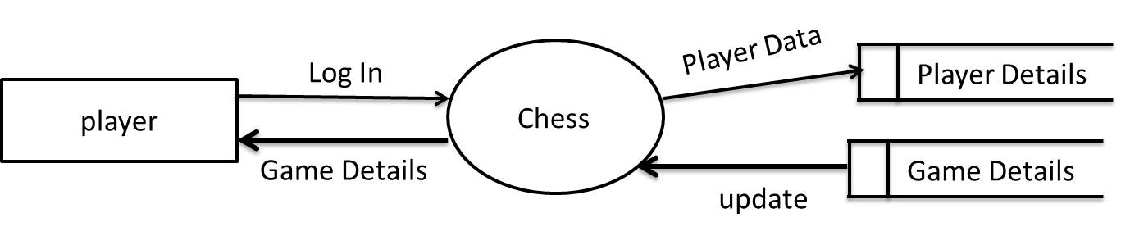

**1st level DFD :**

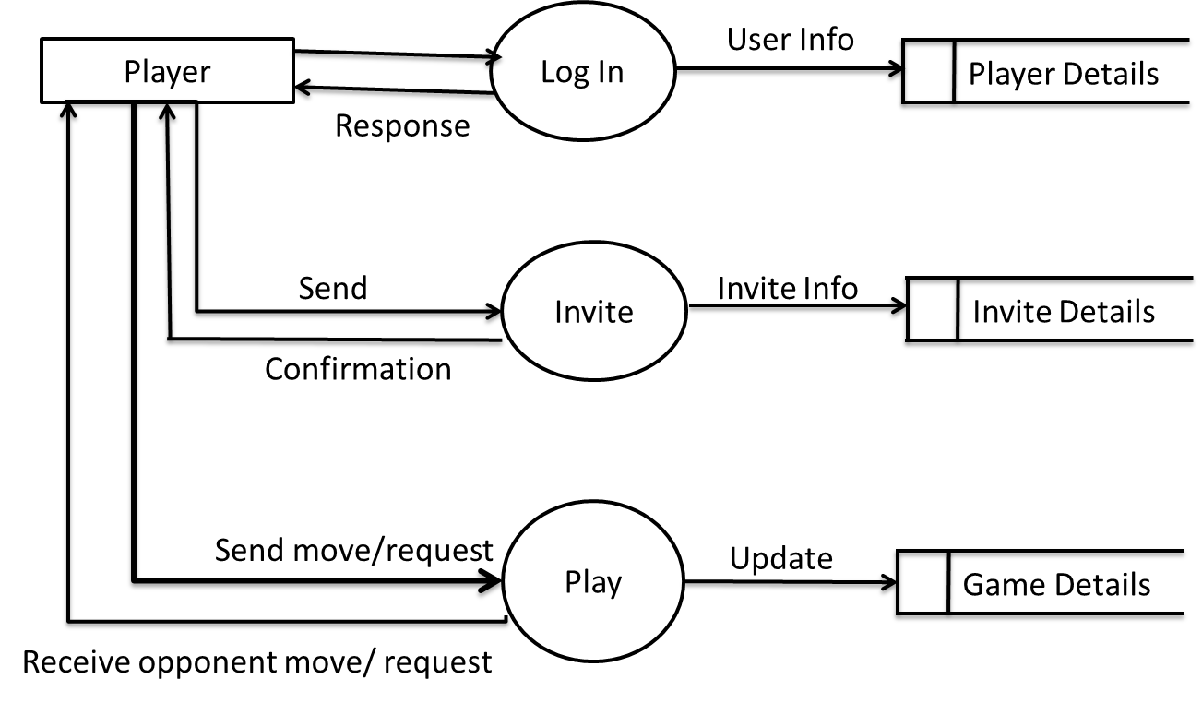

**2nd Level DFD I. :**

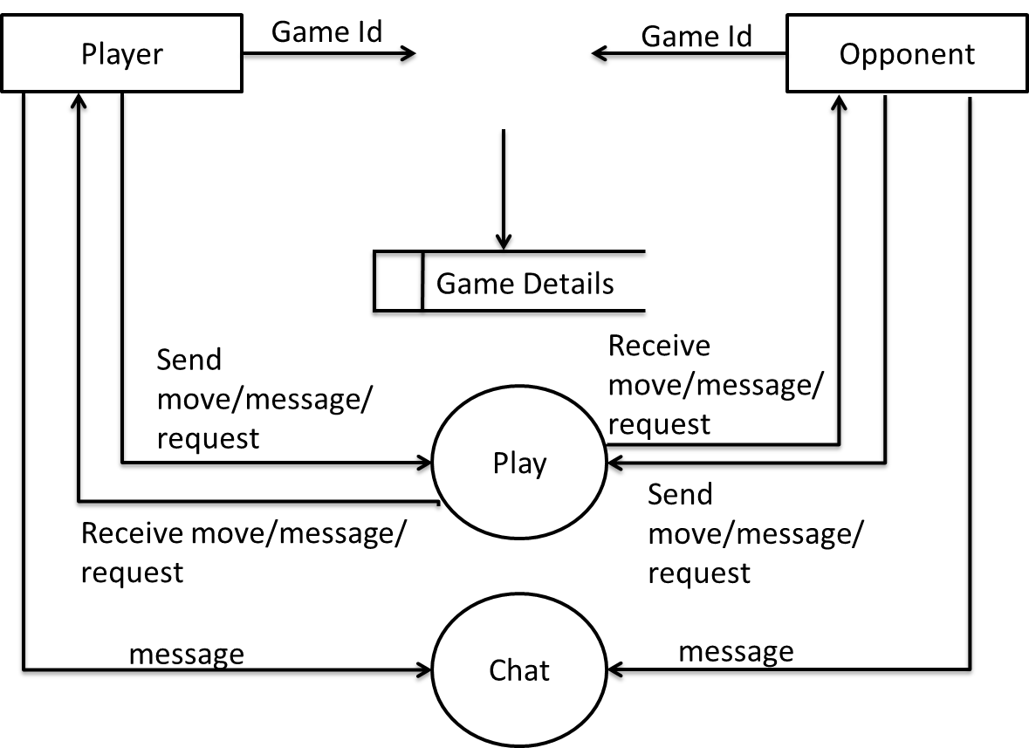

**2nd Level DFD II. :**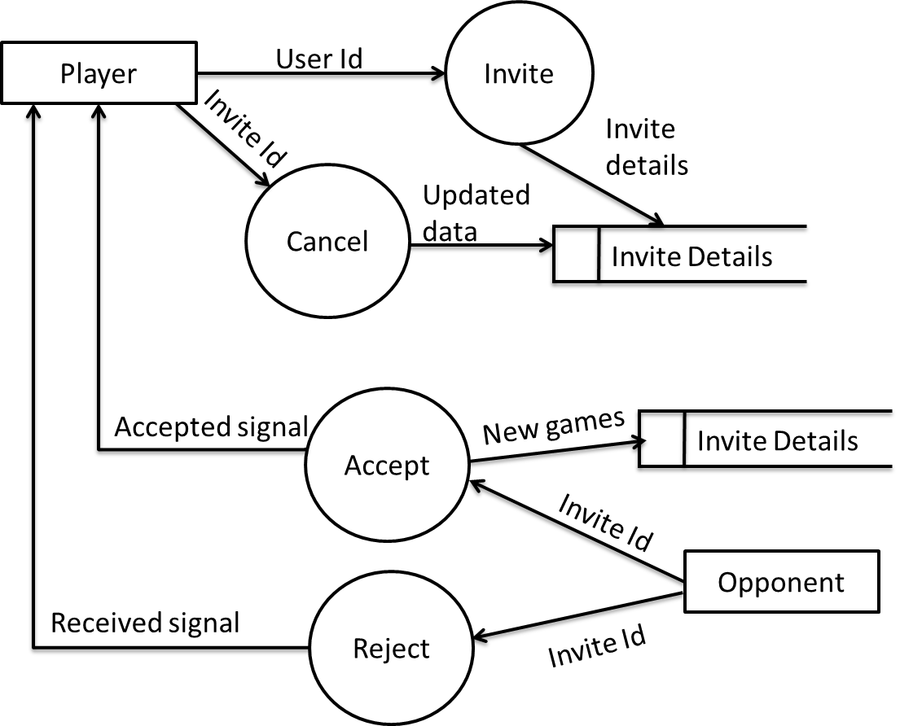

**ENTITY RELATIONSHIP DIAGRAM**

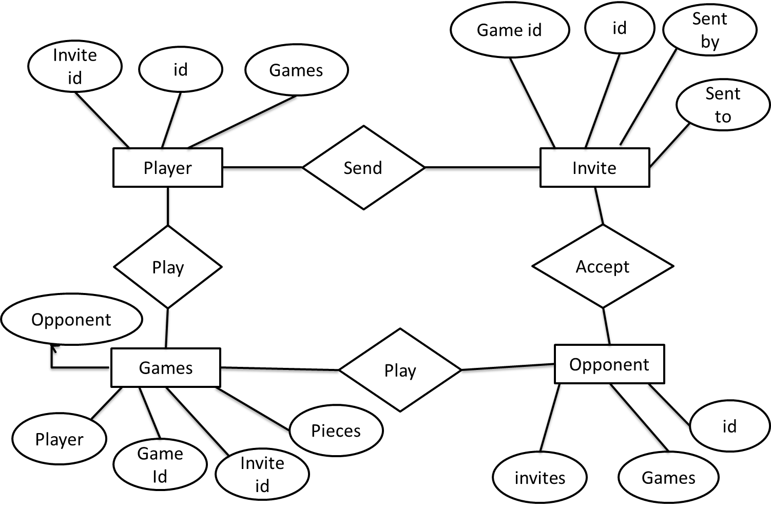

**USE CASE DIAGRAM**

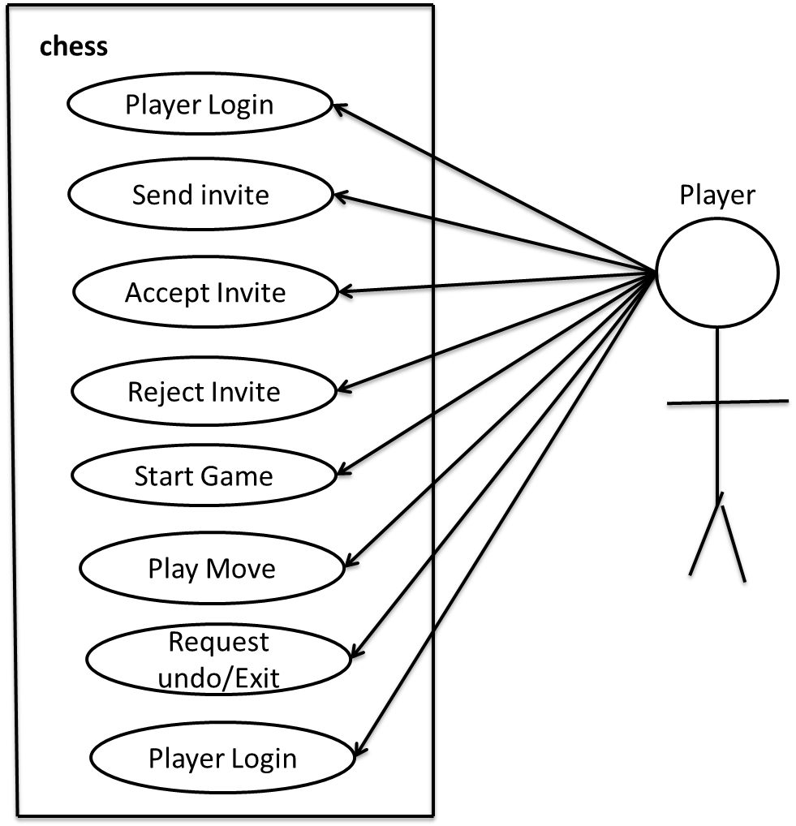

**CLASS DIAGRAM**

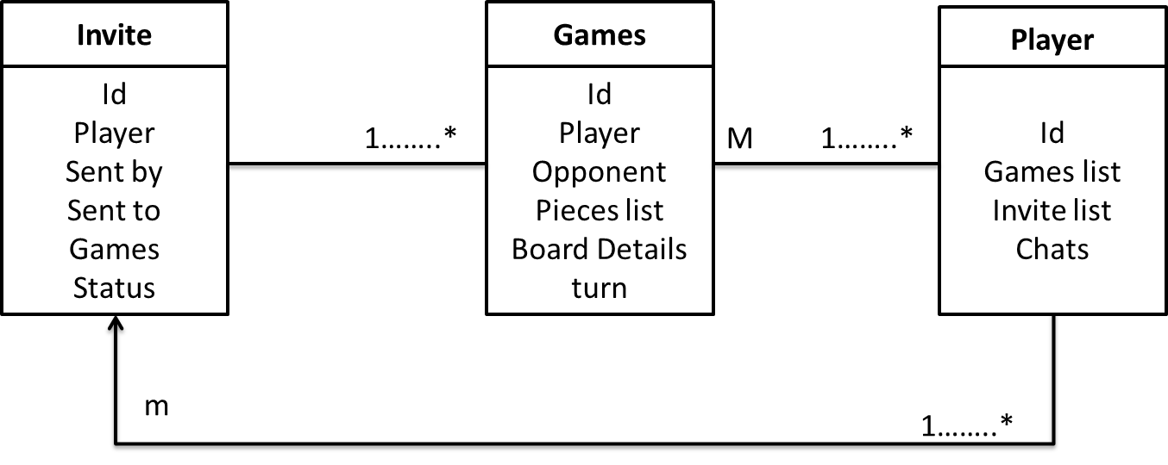

**COMPONENT DIAGRAM**

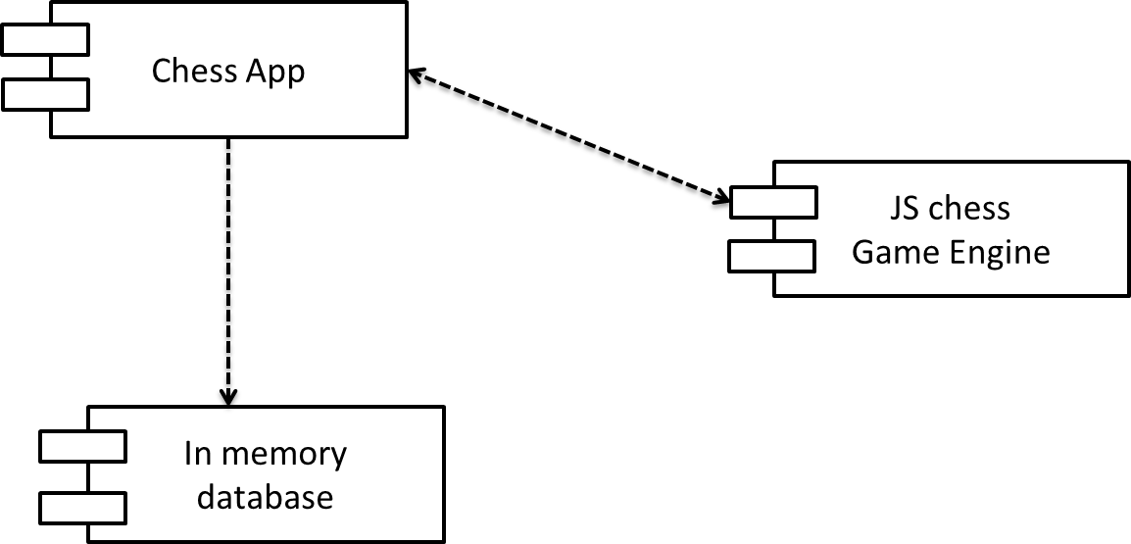

**SEQUENCE DIAGRAM**

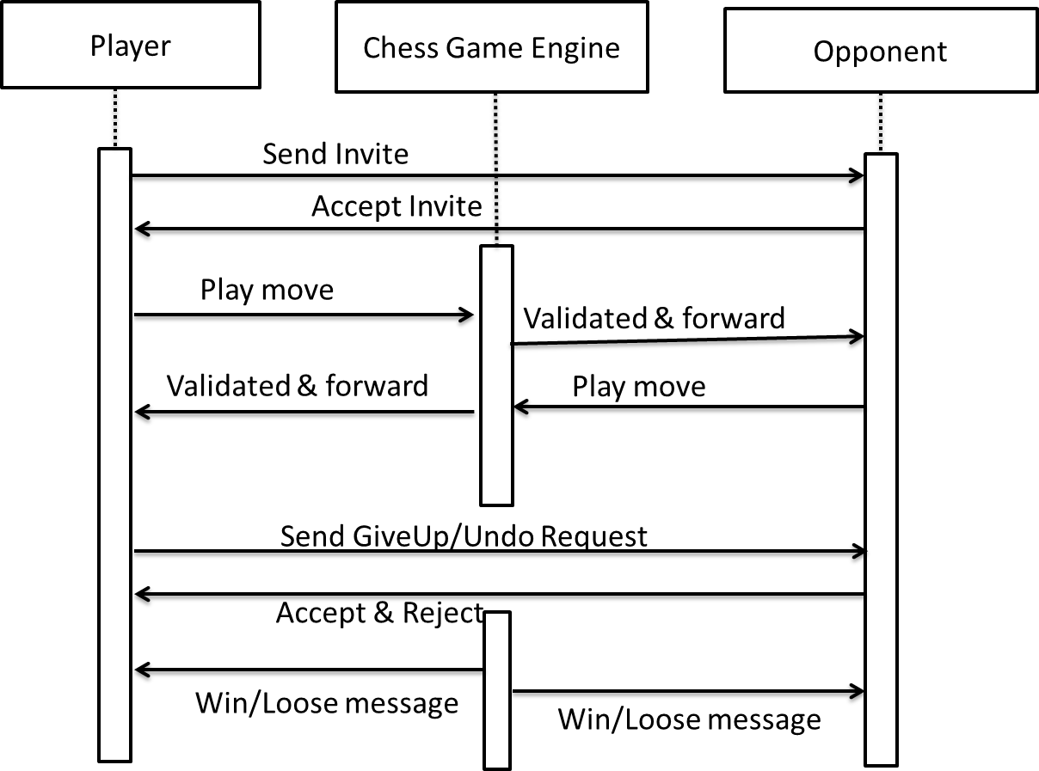

**INPUT SCREENS**

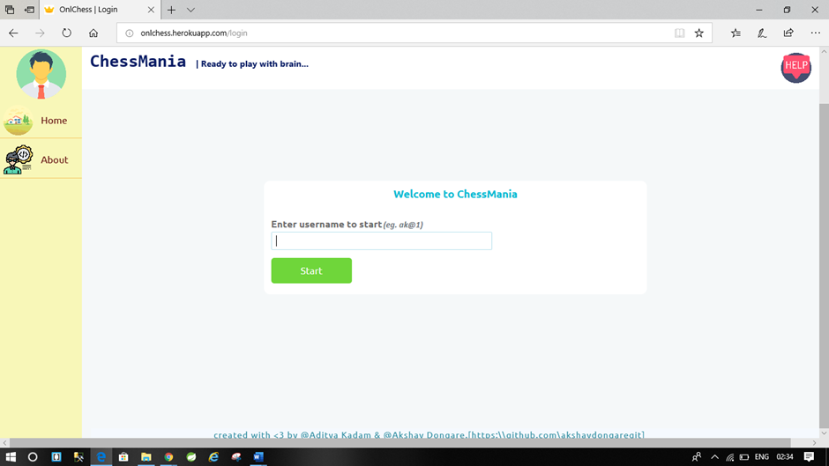

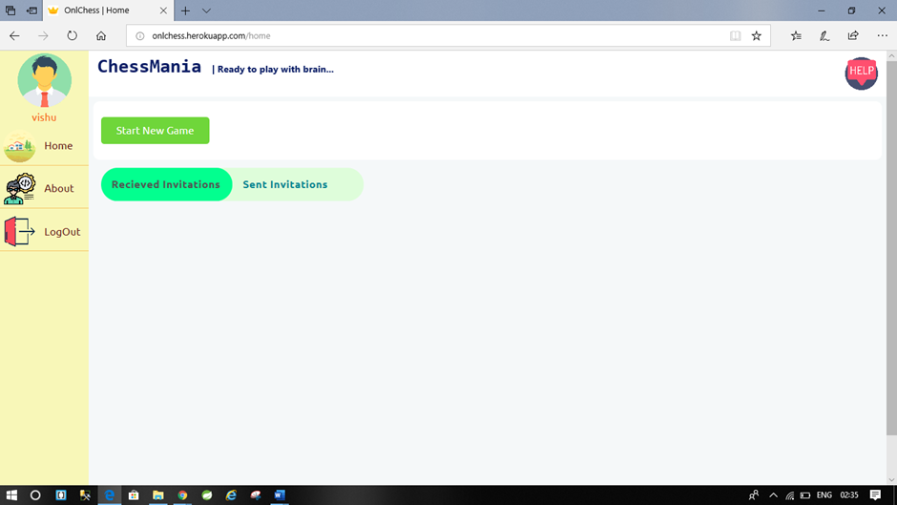

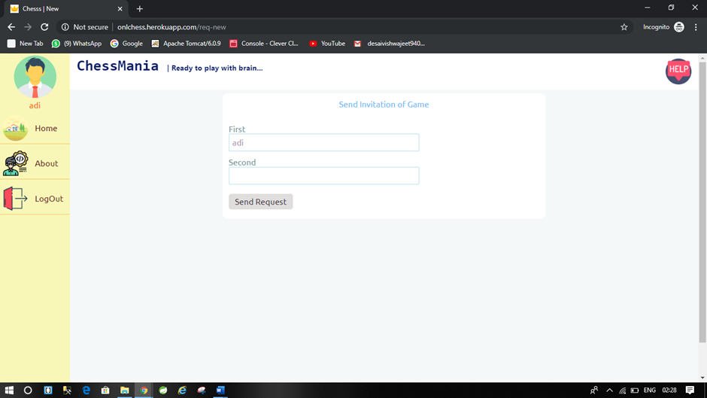

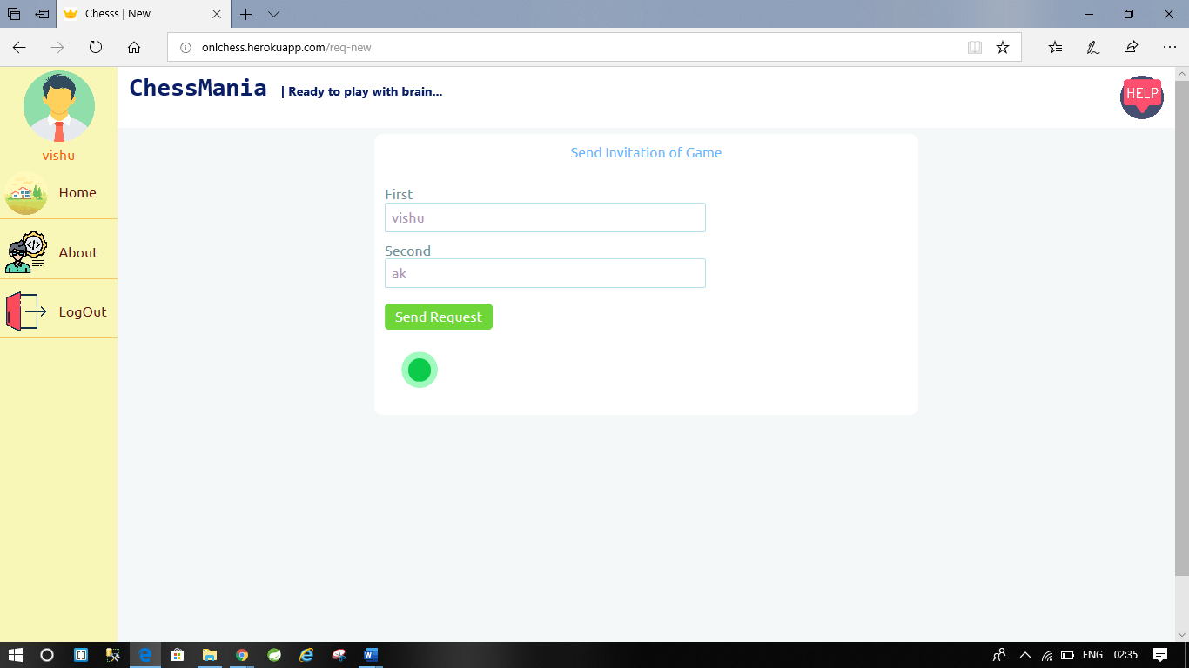

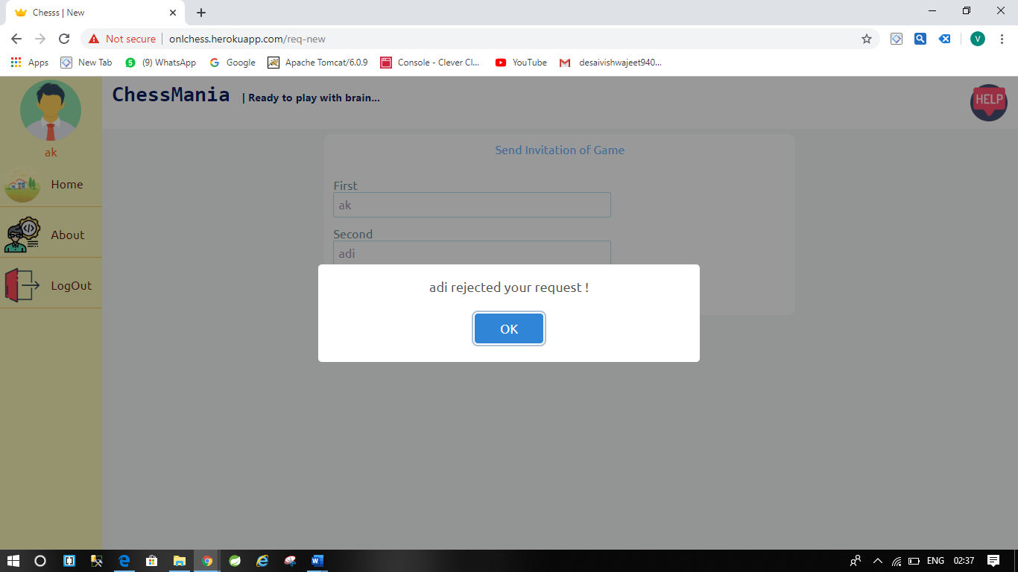

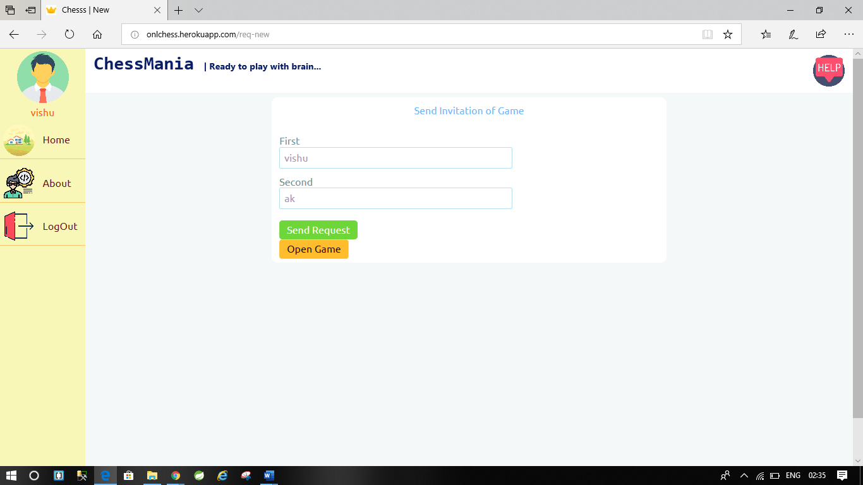

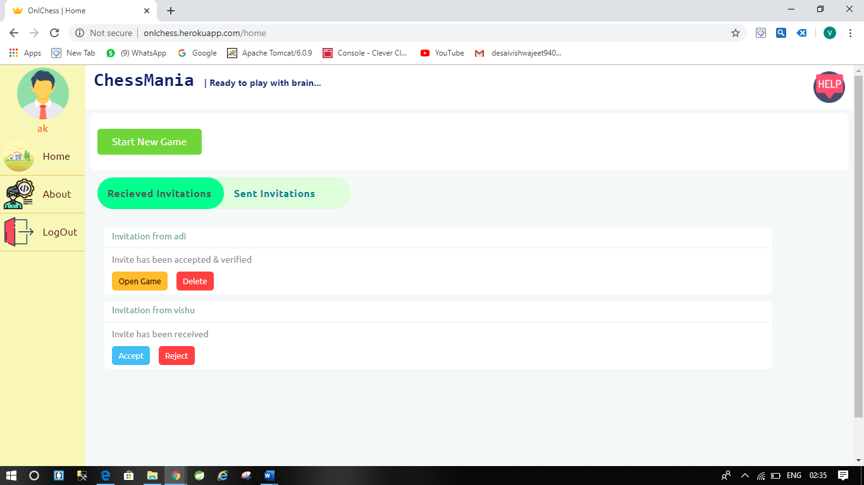

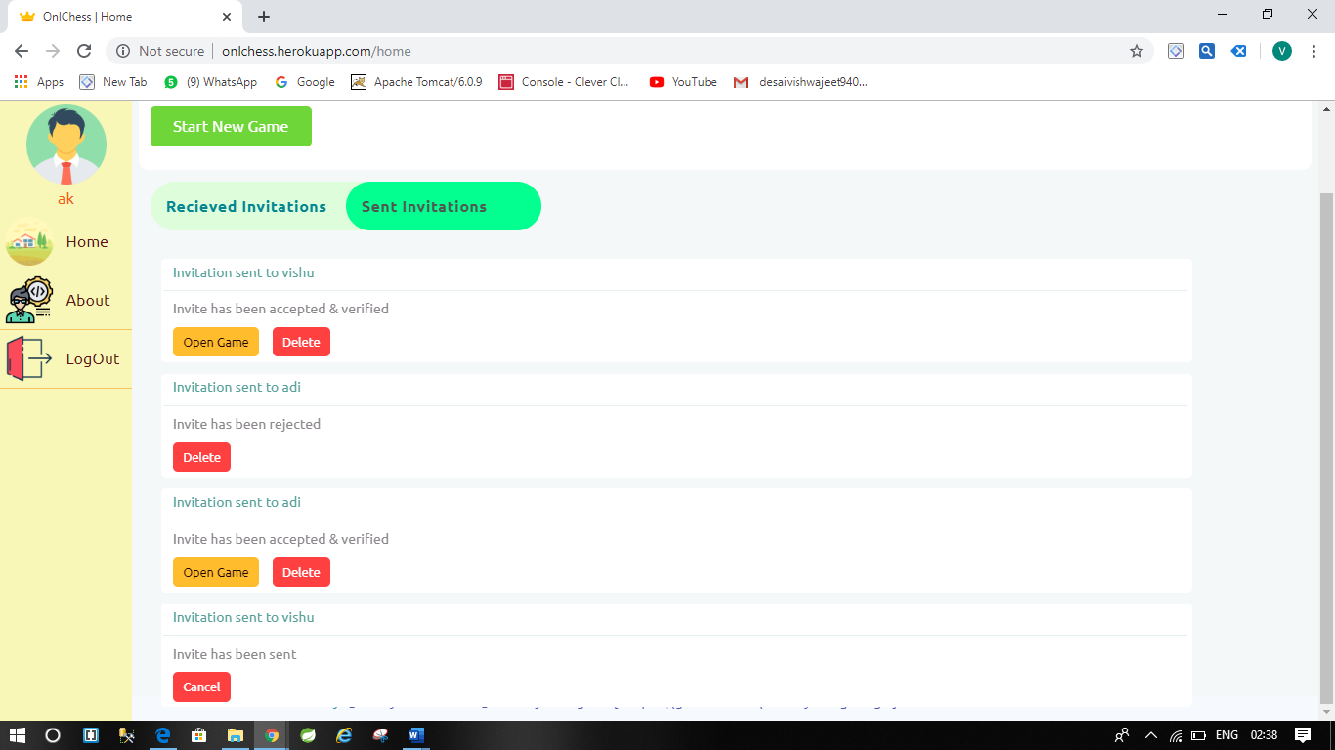

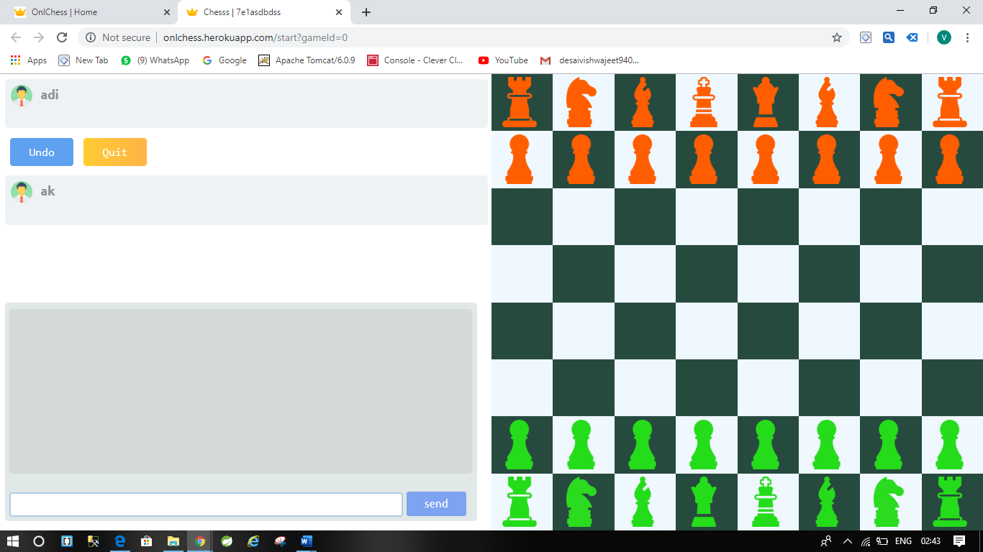

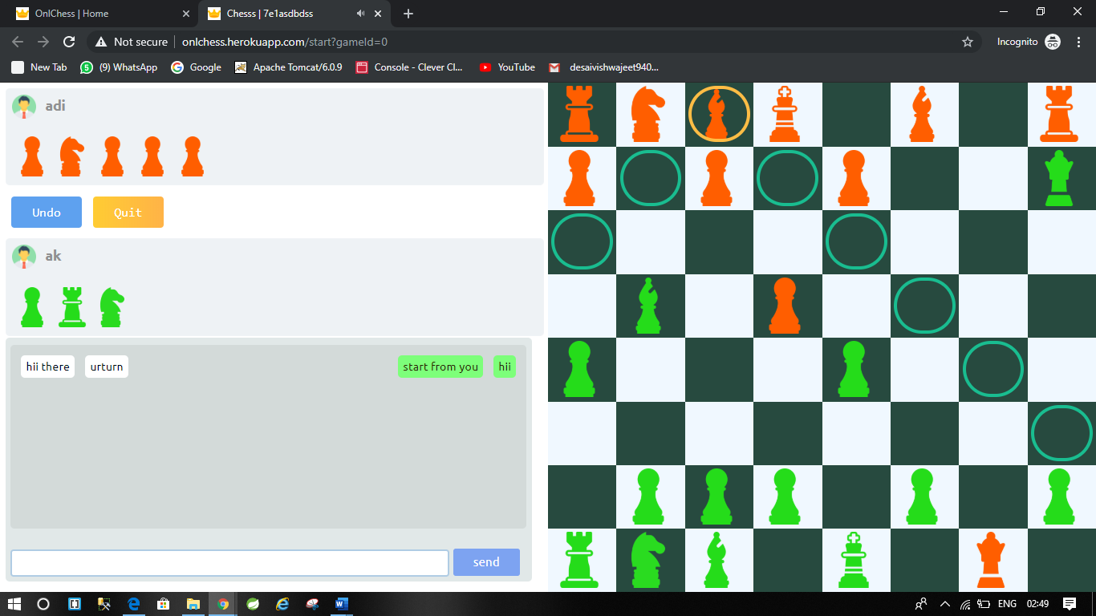

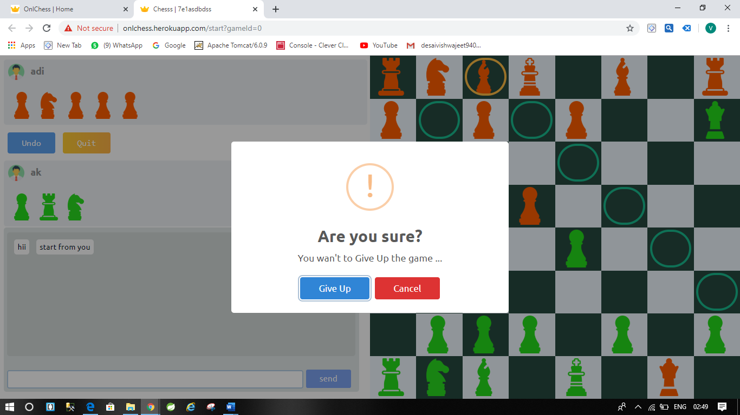

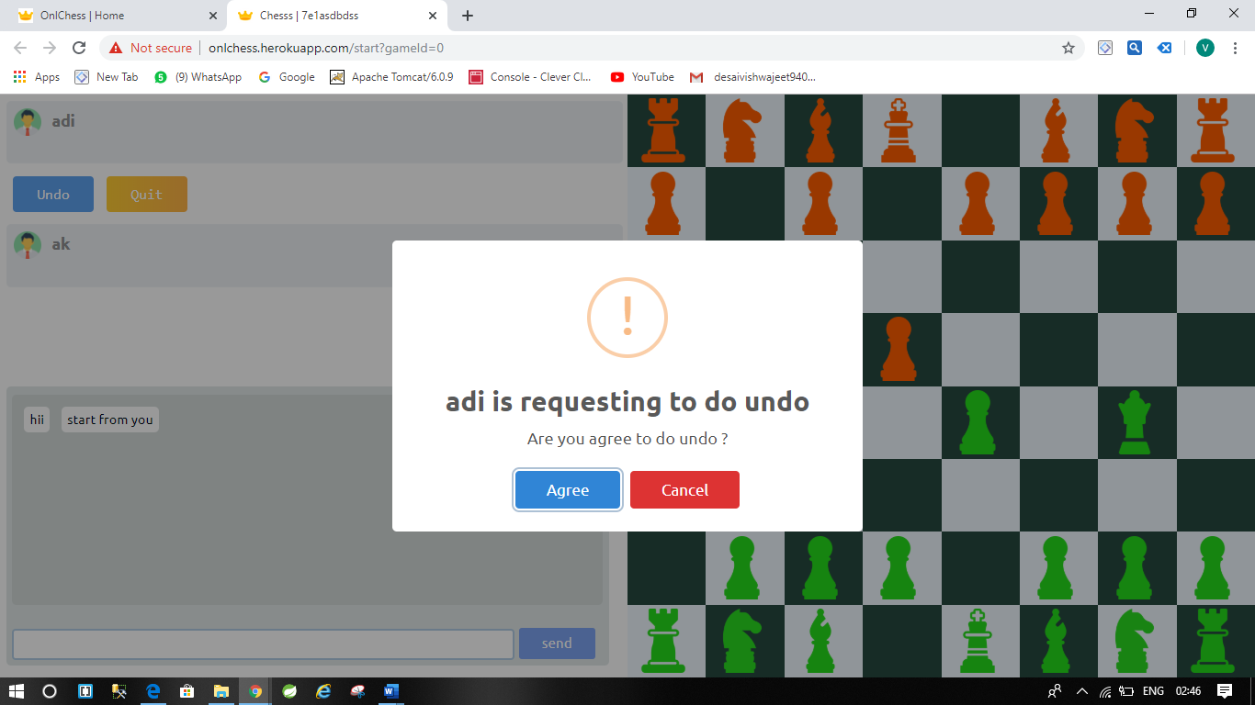

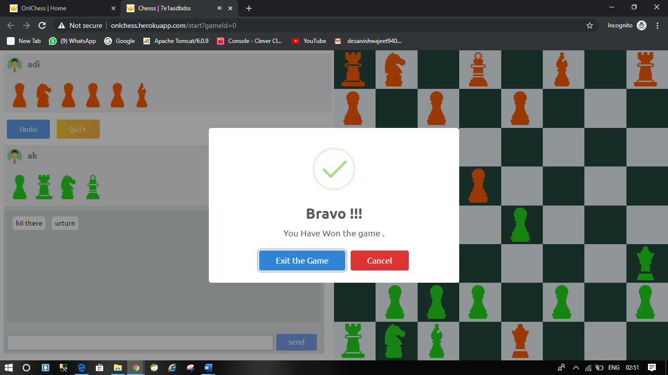

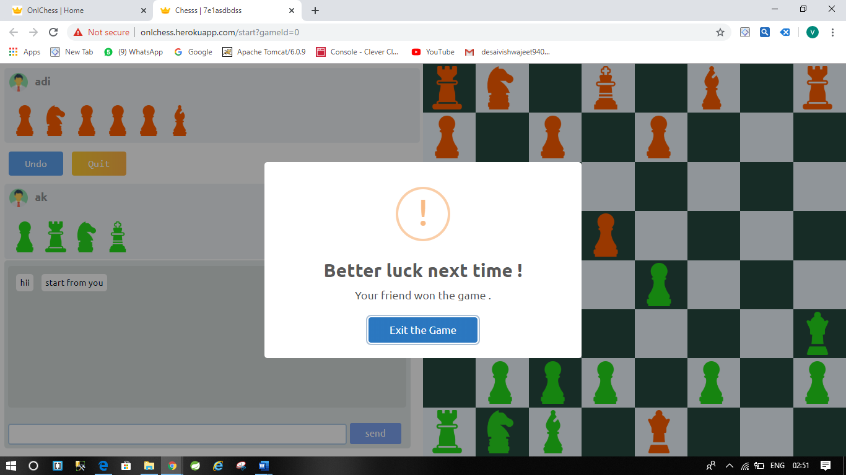

**LIMITATIONS AND FUTURE ENHANCEMENTS**

**Limitations :**

* User can’t search other players by name must know login id of other users.
* User’s details are not persisted in database once logout all data will be lost.
* Two players needed to play the game.

**Future Enhancements :**

* Providing search feature to users.
* Providing signup and login facility.
* Designing CPU player option so that only one user also can play game with virtual opponent which will play using AI algorithms.

**CONCLUSION**

The main objective of project was to develop chess game which will be able to play online with anyone by sending them invite.

While developing the basic game module to send and receive text message i.e. chat is also developed side by side and integrated in main screen of chess board shown while playing.

The developed game has two parts one is main view where user can login send invitations, receive invitations from others and manage invitations. Help page is also provided to user in this module. From this view user can open and start playing game with anyone.

Second module mainly consist of chess board any control to play the game it allows user see chess board, pieces, move pieces and other controls like undo move, give up, exit game. This screen also contains chat window using two players can chat with each other.

**REFERENCES AND BIBLIOGRAPHY**

* NodeJs.org - <https://nodejs.org/en/docs/guides/getting-started-guide/>
* ExpressJs - <https://expressjs.com>
* Socket.io – <https://socket.io>
* Heroku – <https://www.heroku.com>
* Github - <https://github.com>
* Google - <https://www.google.com>
* Tutorialspoint - <https://www.tutorialspoint.com/expressjs/index.htm>
* StackOverflow – <https://stackoverflow.com>